BEFORE THE
COUNCIL OF THE CITY OF NEW ORLEANS

IN RE: RESOLUTION REGARDING
PROPOSED RULEMAKING TO
ESTABLISH INTEGRATED RESOURCE DOCKET NO. UD-08-02
PLANNING COMPONENTS AND
REPORTING REQUIREMENTS FOR
ENTERGY NEW ORLEANS, INC.

Building Science Innovators Comments on
Entergy New Orleans’ 2015 Draft Integrated Resource Plan

Building Science Innovators [BSI] submits these comments regarding the Entergy New Orleans’ [ENO] 2015 Draft Integrated Resource Plan [IRP]. Following the 1) Executive Summary and a Concise List of BSI’s Recommendations, justifications are found in 2) a Critique of the Assertions by ENO and Various Intervenors Presented during the IRP Meetings, as well as, 3) Elaborated Recommendations designed to enhance both the IRP results and IRP process.

1 Executive Summary
BSI is especially interested and applauds the actions of the New Orleans City Council [Council] to direct ENO to regularly engage in a quality IRP process. This is because of i) BSI participation and leadership within the New Orleans Energy Policy Task Force which recommended this NOVEL course of action in 2007, and ii) BSI’s “Inverted Demand Compliant Construction — a Key to a Renewable Energy Future” [IDCC] 2014 original research and leadership at the nexus between building science and utility policy design which established consumer-installed battery systems as cost-effective and suggested that universal adoption may be a necessary step for a sustainable planet.
Received
3:39PM Aug 31, 2015
Clerk of Council
City of New Orleans

ENO’s Draft IRP has fatal flaws and ENO should be directed to revise its IRP to address them.
However, the Draft IRP produced by ENO is fatally flawed and should be rejected by the Council. The Draft IRP is rift with flawed assumptions, modeling errors, and unsubstantiated conclusions. Four of the most egregious errors derive from the serious deficiencies in the way ENO utilized the IRP modelling software. ENO’s four most serious modelling errors (among others) were: 1) failing to include batteries in the model despite the fact that batteries were already price competitive at the beginning of the IRP process and have dramatically declined in price in the past year; 2) failing to perform an industry-standard risk analysis; 3) failing to fully take into account the impact of EPA’s Clean Power Plan, which has been in an open development process for several years although it was formally mandated earlier this month; and 4) failing to consider zero-capital-cost customer-owned solar power plants. A fifth fatal flaw is the “black box” data used by ENO for utility-scale solar. A sixth fatal flaw is that ENO’s demand-side management (DSM) program success is paltry compared to what is already working at other utilities and a robust DSM program can more quickly close the gap between supply and demand than investment in a new, fossil-fueled electricity-generating plant.
With regard to the first error, installing batteries has been known to be more cost-effective than building peaking plants since before the beginning of the current IRP process. With only a few changes in regulatory policy, consumer-installed battery installations were already cost-effective two years ago, prior to the initiation of the current IRP process. Grid-connected battery installations have been recognized by a wide range of experts to have become cost-effective since late-2014, i.e., in the middle of the IRP planning process. The dramatic drop in battery prices during the last year is a game-changing event which goes to the core of ENO’s assumptions and resulting conclusions. Despite all of this, ENO discounted battery storage early on, and this technology was never reconsidered.
With regard to the second error, an industry-standard risk analysis is the result when an extended list of optional solutions and an extended list of variable assumptions and their probability distributions are considered against each other in an automated fashion against various goals including the goal to minimize costs. Without performing an industry-standard risk analysis, ENO concludes that, a 300 MW combustion turbine [CT] is the best choice based upon risk despite the fact that the CT option did not “win” the competition in any scenario. In fact, nothing presented by ENO during the IRP meetings demonstrated that the “do nothing” option is more expensive than building anything, much less a new CT generating plant. The deficiencies in ENO’s risk analysis are well highlighted when ENO’s IRP is compared to the robust risk analyses performed by other utilities utilizing the same or similar IRP-modelling software.
With regard to the third error, ENO’s Draft IRP, published as it was before the recent EPA Clean Power Plan announcement, could only conjecture that the Generation Shift option was a viable scenario. However, following the Clean Power Plan announcement, economic biases against CO₂ production are much more likely and substantial, and will more surely encourage more PV generation. Consequently, this watershed event means that the hypothetical “generation shift” scenario described in ENO’s IRP may now be the most likely scenario. If that were the case, according to ENO’s IRP, the best plan is build a 1.2 GW solar plant, not a 300 MW CT.
Compounding the failure to adequately price CO₂ projection is ENO’s fourth error of only considered a utility-owned solar plant instead of customer-owned solar plants. ENO considered a solar plant within its IRP’s alternative generator choices but determined that the solar option only “wins” the competition for best choice in the scenario that assumes very high CO₂ emission prices; this only happens because of the solar plant’s very high capital costs. However, because customer solar power does not have any capital costs borne by the utility, the solar option should “win” in every scenario.
A fifth fatal flaw is ENO’s use of “black-box” data to develop cost assumptions for utility solar. Instead of utilizing a public report on such cost assumptions, ENO commissioned a “proprietary" report which hides these cost assumptions in a black box which cannot be examined by the other parties or the public. Such black-box data should never be used in an IRP, particularly on a fundamental core issue – the cost of power generation.
A sixth error is to fundamentally ignore the fact that ENO’s demand-side management (DSM) program success is paltry compared to what is already working at other utilities. BSI explains how multiple DSM pathways can be easily employed to fill the projected 300 MW gap between supply and demand fast enough and much more cheaply than building a fossil-fuel-powered generator.
BSI submits that any one of the six preceding errors is a fatal flaw which makes ENO’s conclusion that the best plan is to build a 300 MW CT without credibility. Accordingly, BSI submits that the Draft IRP should be rejected and that ENO should be directed to perform a new IRP utilizing a robust risk analysis similar to that performed by other utilities which takes into account:
- one alternative resource option is “build nothing”
- CO₂ emission price in light of the recent EPA Clean Power Plan announcement;
- economics of battery storage when grid installed vs consumer installed;
- economics of PV when utility owned vs consumer owned; and
- economics of DSM in all four of its various forms:
- Energy-Efficiency,
- Demand Response,
- PV installations, and
- Battery installations.
Furthermore, ENO should be directed not to utilize “proprietary” data prepared by outside parties which cannot be examined by other parties or the public.

The Draft IRP fails to adequately discuss how the closure of the Michoud power plant may affect ENO’s planning reserve margins and ENO’s membership in MISO.

A seventh major error is ENO’s failure to adequately discuss how the closure of the Michoud power plant may affect ENO’s planning reserve margins and ENO’s membership in the Midcontinental Independent System Operator [MISO] wholesale electricity marketplace. ENO has often used this market to supply itself with power or sell ENO’s power when prices were favorable. MISO often has a gross excess supply of power between midnight and 6 AM.

MISO has a membership requirement for a load center like ENO, namely, that ENO’s “Planning Reserve Margin” of capacity must exceed its annual peak demand by at least 12% or 14% and this requirement will grow in the future to over 17% in twenty years. Therefore, shutting down Michoud could jeopardize ENO’s membership in MISO. Because there is over 8,000 MW of capacity in excess of the demand needs within MISO, it is not in ENO’s customers’ best interest for ENO to close itself off from this rich buyer’s market selling power. ENO’s hidden agenda may be to close Michoud down in order to create a shortage in its planning reserve margin requirements so that ENO can claim that because no zonal resource credits (ZRCs) are available to ENO, the only way to remain in MISO is to purchase a portion of another Entergy power plant. BSI urges in the strongest terms possible that the Council must require ENO to have a long-term agreement for the option to buy adequate ZRCs from Entergy in place prior to closing Michoud.

ENO’s IRP’s Main Argument
- ENO’s peak demand is and will be over 300 MW higher than can be economically furnished using its existing generators,
- ENO’s DSM’s success is too slow to ever close the supply / demand gap, and
- The best plan is build a 300 MW combustion turbine [CT] because this option minimizes risk.

BSI’s Response
- BSI agrees with ENO’s first assertion but challenges what ENO assumes is a done deal: that ENO will soon shut down all of the Michoud power station. As noted above, Michoud should not be closed unless ENO can prove that this loss of generation will not adversely affect ENO’s membership in MISO.
- BSI challenges the nuanced implication which ENO has associated to its second assumption that DSM cannot close the gap in a few years.
- Even if the supply / demand gap cannot be closed soon enough with various forms of DSM, BSI submits that ENO presented no credible evidence that the best option is building a 300 MW CT.

BSI recommends revisions in rate structure in order to stimulate DSM which will work together, help finance each other and close the supply/demand gap within a few years.

BSI submits that ENO’s DSM is performing poorly for more than a dozen reasons. This is in sharp contrast to the success of Tucson Electric Power’s (TEP is about 2.5 times as large as ENO) DSM which is projected to continue to experience—twenty times as much as ENO’s DSM’s annual success each year for the next six years. Moreover, TEP’s DSM program lowers peak demand at half of the cost (in $/W) of ENO’s DSM program.

BSI also notes that there is an artificial distinction between various ways to use utility funds to “induce” drops in peak demand, a.k.a., DSM. Traditionally, the term “DSM” has not included any but the first of these ways to reduce demand:
- Subsidizing energy-efficiency retrofits in buildings,
- Using price signals to temporarily lower demand, (known as demand response (DR))
- Subsidizing renewable energy installations, and
- Subsidizing battery installations.
BSI submits that this distinction has been hampering ENO’s DSM program design, grossly slowing down DSM’s success and increasing its costs.

Therefore, BSI recommends that the Council should:

- Not pick the winner, or allocate or segregate resources among these four ways to reduce peak demand, but instead should create a carrot and stick approach that applies graduated charge increases and rebates to engage and transform the marketplace.

- Replace decreasing block rates with increasing block rates for residential customers and increases in the peak demand charges for other customers, as well as a menu of targeted, performance-based rebates. The cost of the rebate program need not exceed 5% of what ENO projected to spend for the proposed solar option. This will empower the marketplace to close the gap. BSI submits that the marketplace will do it faster and cheaper than ENO’s proposal.

- Use the extra income from these rate increases to first completely fund the rebates and then lower the cost of energy for consumers whose consumption is limited to the first block within the rates.

The details of these recommendations are presented in summary form in the next section and in an elaboration of recommendations section at the end of the document.

Recommendations to improve the IRP process.

BSI’s recommendations are not limited to how to close the demand/supply gap. The following recommendations are also given to improve the IRP process. The order of these recommendations reflects BSI’s opinion about their importance.

- Compensate intervenors when their contribution to a regulatory decision saves money.
- Mandate that the IRP process has complete transparency.
- Mandate that the IRP is dynamically responsive to changes in fact.
- Mandate that the IRP conforms to industry standards in IRP quality including, but not limited to risk analysis.
- Mandate that an independent third party produces the analysis, run the meetings, and collect and publishes information.
- Provide for a minimum test for passing or failing the IRP process.
BSI also notes that similar tests should be instituted for other regulatory processes like the design of the DSM program and ENO’s rate design.

BSI Supports Decoupling by which ENO can earn a profit without investing in new power plants.

ENO has an economic incentive to bias its IRP towards investing in new generation plants. The contract between ENO, ENO’s ratepayers and the City of New Orleans is conventional and provides two stipulations: i) all cost of electricity is passed through to the customer with no profit, except that ii) the IOU is allowed to make a “fair” profit on capital improvements. There is currently a docket where ENO, the Council and intervenors are working on “Decoupling”, i.e., finding an agreed upon alternative mechanism where the utility can make increasing profits without adding new capital investments. Although BSI is not an intervenor in that docket, BSI supports that process. BSI wants ENO to earn more profit without adding new generating equipment.

Accordingly, BSI recommends:
- ENO should not be allowed to own new generating plants; instead
- ENO should be rewarded for facilitating a future where the ratepayers of New Orleans have lower electricity bills, enjoy improved electricity outlet reliability, and use less fossil-fuel generated electricity.

2 Concise List of BSI’s Recommendations

How should the Council engage City of New Orleans [CNO] ratepayers and the construction industry to rapidly and economically reduce peak demand in sufficient size and speed?

BSI believes any one the following three methods CAN displace 300 MW of peak demand in 5 years.
- Incentivize much more robust, extensive, and cost-effective energy-efficiency retrofits (a.k.a., demand-side management [DSM]) by utilizing many of the means described in the Elaborated Recommendations section at the end of this document.
- Incentivize the installation of battery energy storage systems [BESS] in every building.
- Incentivize and provide legislative support for Community Solar in two ways:
  - Promote 75kW to 3 MW solar farms at distressed property found all around the city.
  - Promote a system of small, 50 to 100 KW solar farms with 150 to 300 kWh of integral battery storage on many “key lots” of the city.
BSI considers all of the above, as well as Demand Response, forms of DSM.,

The Council should not pick the winner, allocate or segregate resources among these ways to reduce peak demand, but instead create carrot and stick mechanisms of graduated charge increases and rebates to engage and transform the marketplace.
- Install smart meters throughout the ENO building stock. Each smart meter should have the ability to report consumption every 5 minutes. Residential customers should be the last to get them because they are the smallest users per building. In order to be eligible for rebates, discounts or power quality sales, customers must have smart meters.
- Change the rate structure from declining blocks to inclining blocks.
- Change the demand charge found in all except residential customers bills to a utility peak demand charge from what the customer had been paying as a demand charge by equal steps each year for five years until $20/KW/month. Utility Peak Demand for a building is the maximum measured KW consumption rate during any consecutive 15-minute period within the utility’s 3 to 6 hour peak demand time of any day for a month of readings.
- Customers earn a 50% demand charge discount if they buy into a solar farm or install a rooftop system sufficiently large to displace at least 30% of their annual consumption.
- Rule that kWh’s generated at a solar farm cannot be banked for future use; energy not consumed in a five-minute generation period is used to discount bills for low-income ratepayers. Even better, set 10% as the preset amount allocated to low income.
- Facilitate solar farms on key lots and/or economically distressed real estate.

- Institute a rebate schedule to incentivize reduction in peak demand. Define “↓peak watt for 10 years” as the 10-year average demand drop during utility peak hours.
  - Provide a $1.50/“↓peak watt for ten years” rebate for an energy efficiency retrofit that reduces the annual bill of a particular consumer by at least 10%; accept RESNET certified, Home Energy Raters as 3rd party verifiers; CNO retains ownership of associated White Certificates [WC].,,,
  - Provide a $0.75/“↓peak watt for ten years” rebate for purchasing part of a PV system. The utility retains ownership of the ZRC for the purposes of MISO but not an equity interest in PV systems partially financed this way. The CNO retains ownership of the associated Renewable Energy Credits [REC].,
  - Provide a $0.50/“↓peak watt for ten years” rebate for any purchase of part of a BESS. The utility retains ownership of the ZRC for the purposes of MISO but not an equity interest in battery systems partially financed this way.
  - Provide a $0.20/”↓peak watt for ten years” rebate for any other kind of retrofit.
- Provide a mechanism whereby any ENO customer can sell power quality services, i.e., spinning reserve and/or frequency regulation, to ENO or MISO at competitive rates.
- Mandate that Real Estate Multi-listing services publicize energy ratings if available.
- Invite input by educational institutions, other industries or NGO’s to propose regulatory changes or rebates that can invite their services or further lower ENO’s DSM costs.

What should ENO do while waiting for these peak demand programs to have their full effect?

- ENO should continue to satisfy unmet peaking energy needs with power from MISO.
- ENO should stop adding generation resources to the rate-base now and for the foreseeable future.
- The Council should terminate the existing regulatory paradigm by which ENO makes more profit only by building more generators and replace it with a new decoupling paradigm which rewards ENO for efficiency in delivering energy services.
- The Council should remove DSM from ENO’s control and place it under the control of a third party administrator.

What should the Council do to ensure that this IRP process and future IRP processes find optimal results?

Compensate intervenors when their contribution to a regulatory decision saves money.

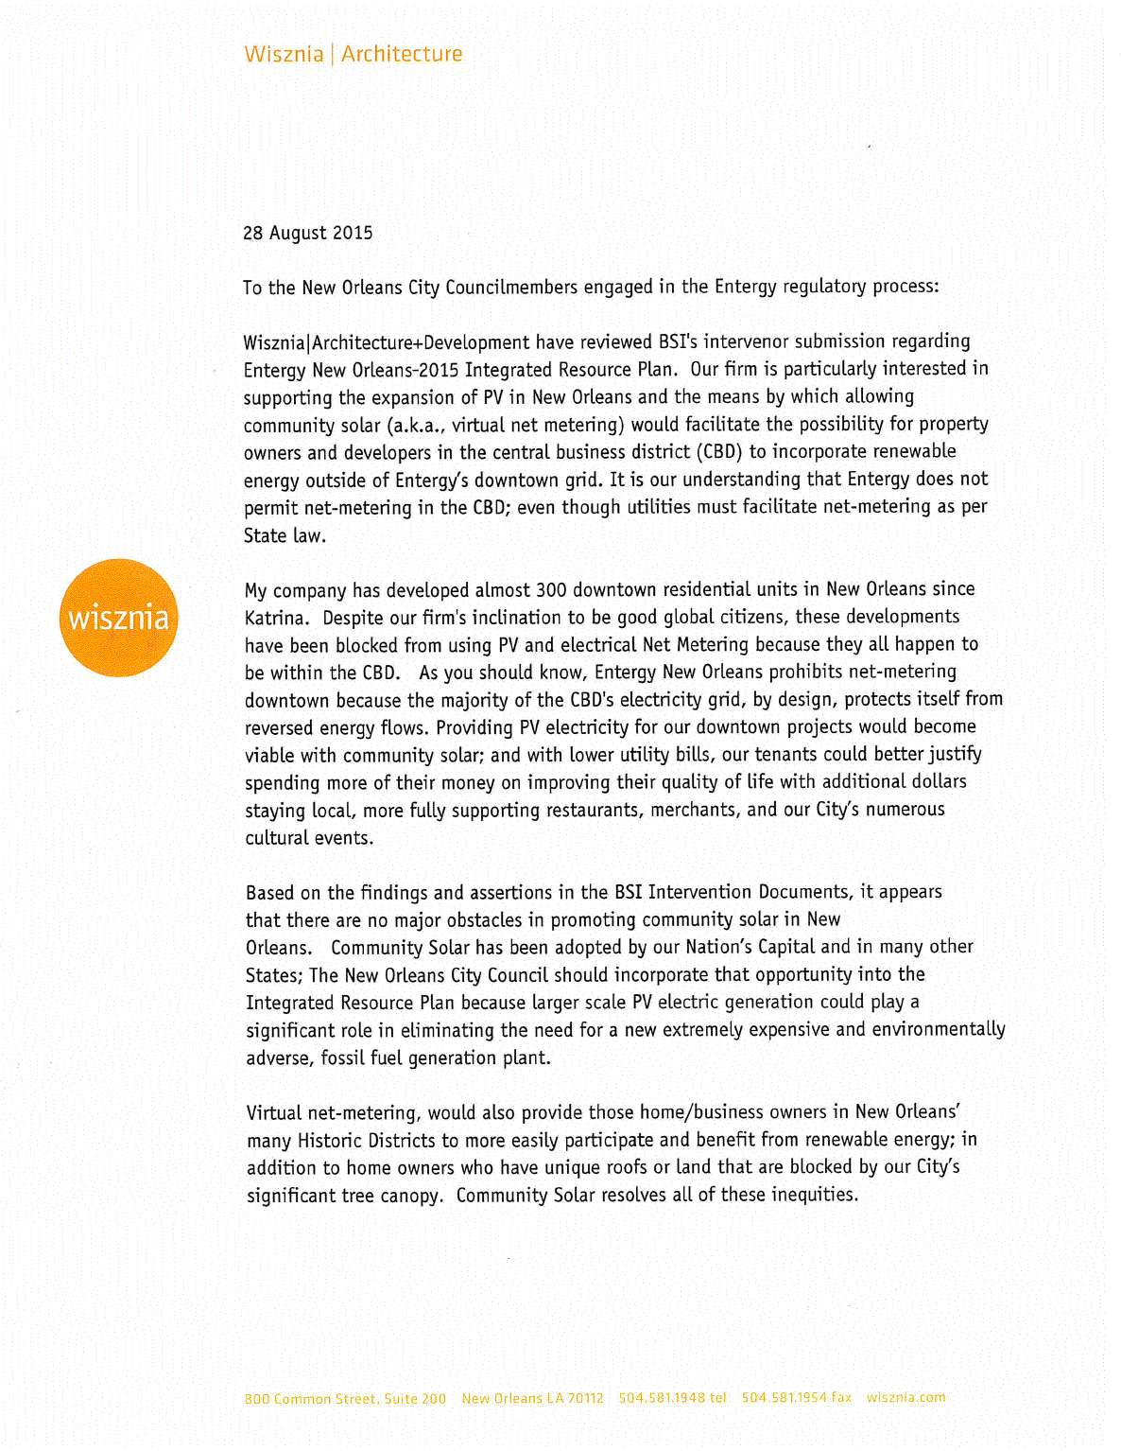
Appendix E — Letter of Support — Wisznia Architecture + Development

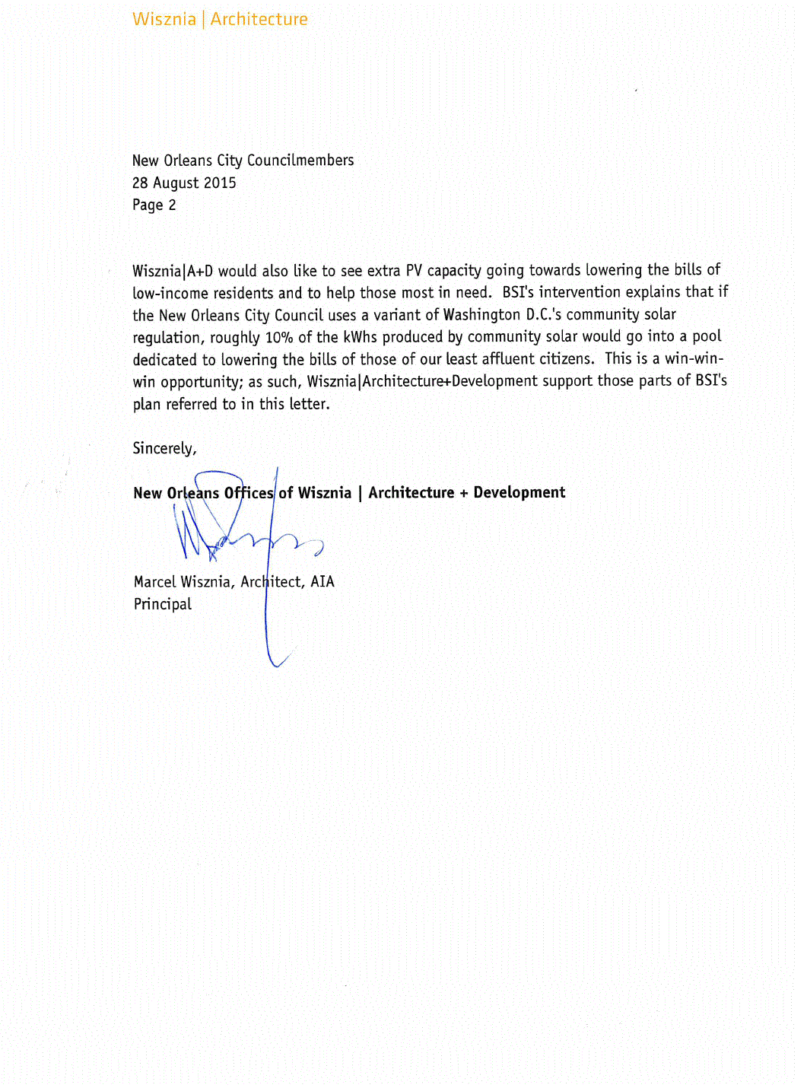

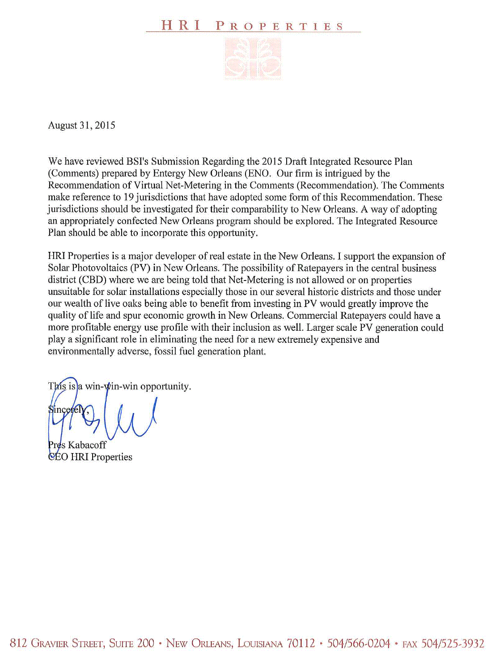
Appendix F — Letter of Support — HRI Properties

Appendix G — Inverted Demand Compliant Construction — A Key to a Renewable Energy Future

https://www.dropbox.com/sh/8583a6d9udm954v/AADl_4oznkirNiJGo9UbW8dJa?dl=0

Endnotes

BSI, LLC, 302 Walnut St, New Orleans, La 70118, 504-343-1243, Myron.Katz@EnergyRater.com
These comments were written by Myron Katz. By far, the biggest content and editorial help was provided by Thomas Milliner. Valuable review assistance was provided by Jaye Hakes, Eli Oppenheimer, Dan Weiner and Norman Witriol. Editorial assistance was also provided by Sharon Katz.
This document references “Inverted Demand Compliant Construction, a Key to a Renewable Energy Future,” a presentation by BSI at EEBA’s September 2014 national conference, “The Energy Hawk”, published in 2007 by the New Orleans Energy Policy Task Force, as well as cited references.
Email communication between Casey DeMoss and Timothy Cragin, August 26, 2015 and August 31, 2015.
Zonal Reserve Credits are interests in otherwise under-committed generating capacity that can be purchased from other MISO entities to avoid this problem.
https://www.tep.com/doc/planning/2014-TEP-IRP.pdf, page 197.
https://www.tep.com/doc/planning/2014-TEP-IRP.pdf TEP’s 2014 IRP predicts a 40 MW drop in peak demand from their energy efficiency program every year until 2020. Why? Because the state of Arizona mandated it.
In a private communication on August 12, 2014, Joananne Bauchman, Business Development and Sales Manager of Vermont Energy Investment Corporation, expressed her opinion that classical DSM artificially separates — allowing rebates for in energy efficiency investments but not for solar or batteries; that is why DSM is renamed in NY.
Demand response (also known as load response) is a temporary reduction to the electricity usage in response to power grid needs or shifting the electricity usage during periods of peak demand or other grid constraints.
This helps to generate a desire for smart meters and a back-up means of quality control for rebates.
https://q9u5x5a2.ssl.hwcdn.net/-/Media/Missouri-Site/Files/environment/renewables/irp/irp-chapter8.pdf?la=en, page 75.
This does not need to create an increase in demand charge because some buildings like churches will see a drop in this charge; conversely, some homes that operate like a commercial building should be required to pay this fee.
California’s utilities commonly have this discount. — Private communication, B Ward, Solar City executive, 8/15.
Washington D.C.’s utility regulator applied this approach for solving the non-participant test for solar farms.
Why reinvent the wheel? RESNET’s rating providers are required by their industry to provide quality control.
BSI believes that performance-based rebates can easily outperform price-based if there is good quality control.
$1.5/W was chosen because the BSI Critique showed that ENO has been paying $1/W for DSM but is willing to pay $5/W for a plausible PV system in its IRP; the PV system was picked as most economical in one scenario.
https://en.wikipedia.org/wiki/White_certificates; some regulators require their IOU’s to buy and trade WC’s.
By demanding a minimum 10% reduction in consumption, low-hanging fruit cannot be the only fruits of success.
This has highest priority; this one should be implemented yesterday, since most solar tax subsidies end in 2016.
http://www.epa.gov/greenpower/gpmarket/rec.htm; EPA’s recent Clean Power Plan will make this lucrative.
BESS can be more cost-effective than PV and has a much greater ↓peak demand potential per dollar invested.
E.g., putting timers on electric water heater that keep them off between 6 AM and midnight; this is too cheap.
A BESS in a home, sized to provide emergency back-up power for a week, can earn $150/month with this tariff.
This idea was already implemented in Gainesville, FL for their utility — zero cost and engages the marketplace.
Currently, before Michoud is shut down, ENO buys power from MISO because it is cheaper than making electricity with the low efficiency generators within Michoud. ENO did not show in its IRP that a healthy contribution of DSM like proposed above could not decrease demand faster than ENO could build a new generator. No convincing evidence shows that ratepayers will be paying less for energy in 2019 (the earliest possible time that a new generator can come on line) with a new generator instead of more investment in DSM.
ENO’s IRP did not consider installing batteries to decrease the needed size of the alternative PV system by a factor of four; but it did show that if that PV system capital cost were one-fourth as much as modelled, it would have been deemed the lowest cost alternative in every scenario. BSI has shown that BESS storage without PV is more cost effective than PV without BESS and BESS added to PV can change the percentage of usable “on peak” output of a PV system from the 25% ENO assumed to two to six times that amount.
Decoupling the incentive for the utility to only make a profit by building new generators is supported by BSI.
As long as ENO runs the DSM it can be expected to discourage improvements in its effectiveness.

